**27/12/2004**

**Program -1.1 :- Demonstrating Html Head Tags**

**Program:-**

<!DOCTYPE html>

<html lang="en">

<head>

</head>

<body>

<h1>Hello World</h1>

<h2>Hello World</h2>

<h3>Hello World</h3>

<h4>Hello World</h4>

<h5>Hello World</h5>

<h6>Hello World</h6>

<p>This is sample program of hello world in different sizes</p>

</body>

</html>

**Output:-**

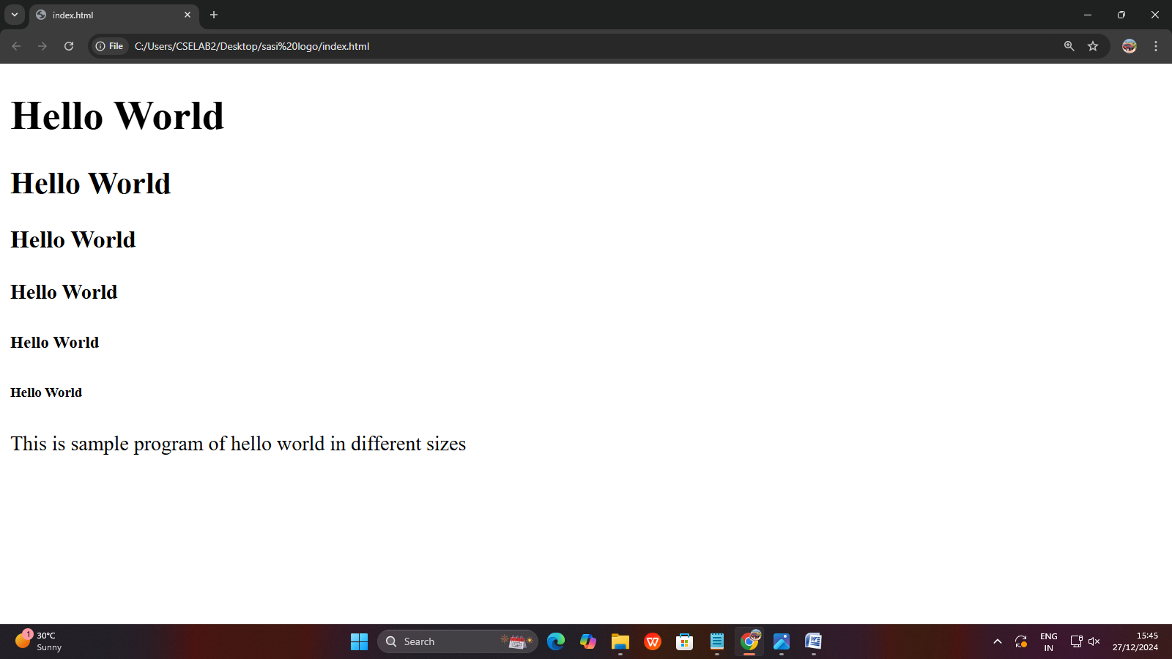

**27/12/2004**

**Program 1.2 :- With HR Tag**

**Program:-**

<!DOCTYPE html>

<html lang="en">

<head>

</head>

<body>

<p>

<h1>Hello World</h1><hr>

<h2>Hello World</h2><hr>

<h3>Hello World</h3><hr>

<h4>Hello World</h4><hr>

<h5>Hello World</h5><hr>

<h6>Hello World</h6><hr>

<p>This is sample program of hello world in different sizes</p>

</p>

</body>

</html>

**Output:-**

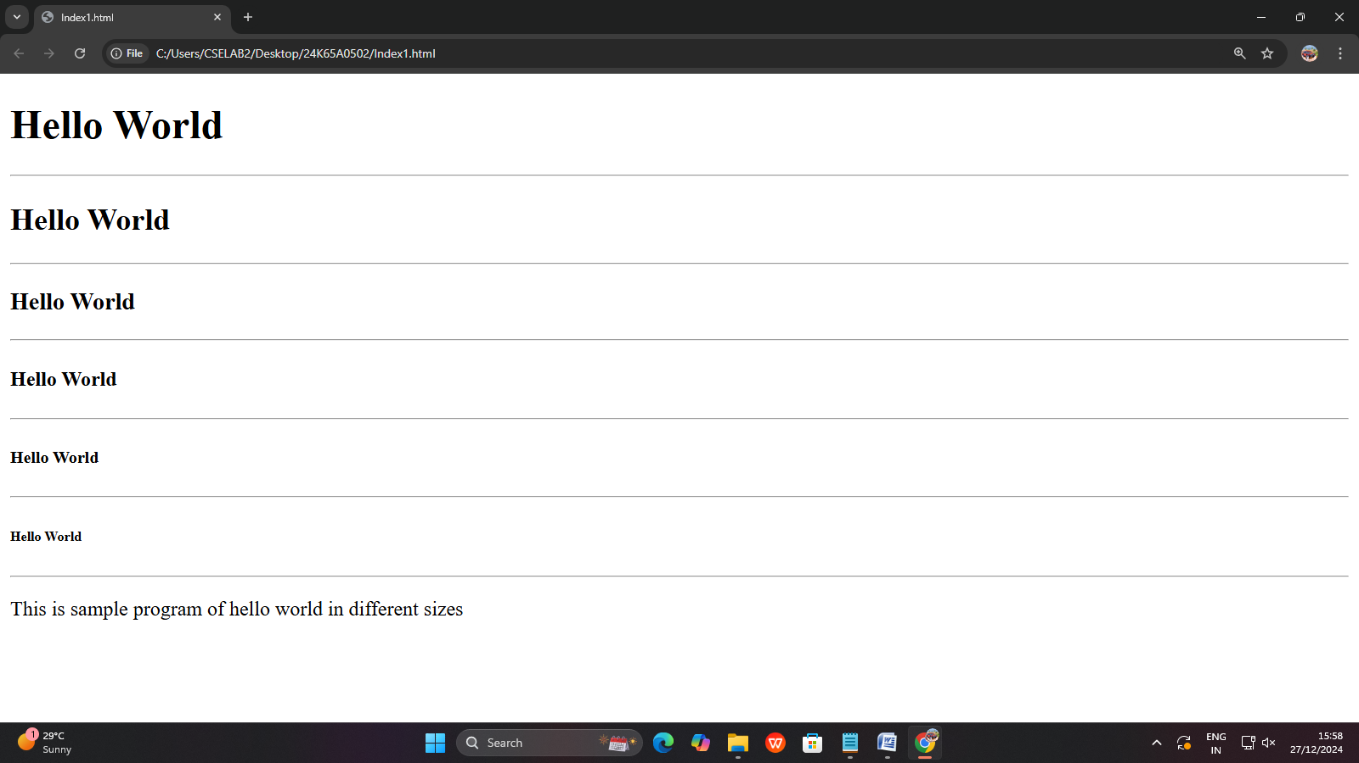

**27/12/2004**

**Program 1.3:- With Align Attribute**

**Program:-**

<!DOCTYPE html>

<html lang="en">

<head>

</head>

<body>

<h1 align = "center">Hello World</h1>

<h2 align = "right">Hello World</h2>

<h3 align = "left">Hello World</h3>

<h4 align = "center">Hello World</h4>

<h5 align = "right">Hello World</h5>

<h6 align = "left">Hello World</h6>

</body>

</html>

**Output:-**

